RESEARCH AND DEVELOPMENT

To estimate impact of R&D on market, it is necessary to calculate quality of products before and after R&D implementation. Quality of products is measured in units from 60, as described in topic [product quality estimate](https://gmcworld.org/blog/product-quality-estimate). When you get MINOR, it is immediately implemented in production in current period (+6 units). Effect on demand from implementing MINOR and getting MAJOR is equal (+6 units). Effect on demand from implementing MAJOR is +20 units.

Effect on demand from R&D operates throughout all 5 periods. Factor elasticity is different for each market and product, because depends on external factors - market load and opponents R&D.

Lets look how R&D developments work with market on scenario 12C3. Scenario 12C3 is rich in R&D developments, which are "hidden" in company's history. 1 product is not implemented 2 MAJOR, 2 product - 3 MAJOR, 3 product - 1 MAJOR. In 1 period we implement hidden MAJOR developments and compare the difference in demand with teams where development has not been implemented.

**Scenario 12C3 - Product 1 (EU and Nafta)**

For 1 product in 1 period implement 2 MAJOR developments and receive 1 MINOR. Increased quality can be calculated by formula:

*96 (1 product quality before implementation) + 2 * 20 (MAJOR) + 6 (MINOR) - 8 (obsolescence) = 134 (1 product quality after implementation)*

Horizontal - absolute value of product quality. Vertical - relative change in demand compared with previous period.

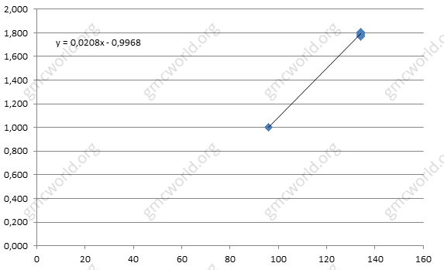

1 product elasticity for EU and Nafta is approximately equal to the coefficient 0,0208. It means that product quality increasing by 1 unit will get 2,08% demand.

**Scenario 12C3 - Product 1 (Internet)**

1 product elasticity in Internet is less than 2 times, coefficient of 0,0100.

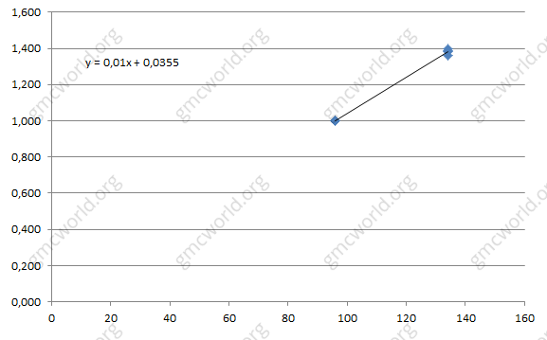

**Scenario 12C3 - Product 2 (EU and Nafta)**

For 2 product implement 3 MAJOR developments and receive 1 MINOR, product quality increasing is calculated by formula:

*95 (2 product quality before implementation) + 3 * 20 (MAJOR) + 6 (MINOR) - 8 (obsolescence) = 153 (2 product quality after implementation)*

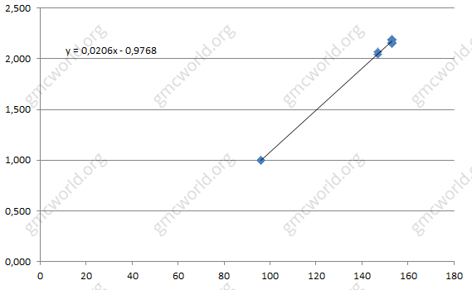

2 product elasticity in EU and Nafta is approximately equal to the coefficient 0,0206, almost the same as for 1 product.

**Scenario 12C3 - Product 2 (Internet)**

2 product elasticity in Internet, coefficient 0,0071.

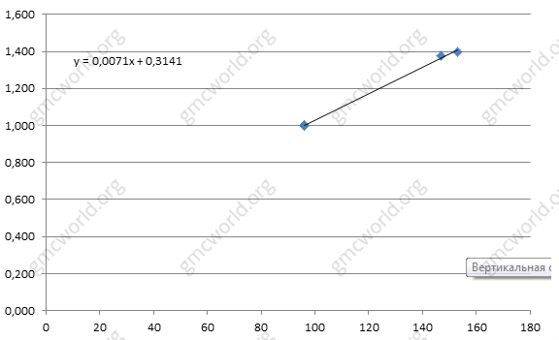

**Scenario 12C3 - Product 3 (EU and Nafta)**

For 3 product implement 1 MAJOR and receive 1 MINOR, product quality has increased from 157 to 176. Elasticity for 3 product for EU and Nafta is equal to 0,0054.

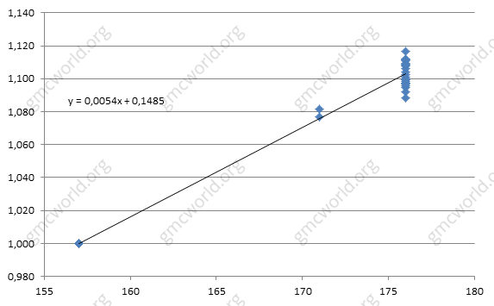

**Scenario 12C3 - Product 3 (Internet)**

3 product elasticity in Internet is 0,0022.

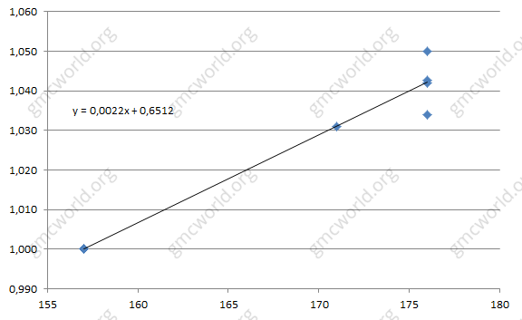

Difference between elasticities of markets and products is primarily due to the different market load for each market cell. The biggest elasticity of R&D factor is reached for 1 product in EU and Nafta, where market load is about 20-30%, while for 3 product in EU and Nafta market is occupied by 50-60% and elasticity is minimal.

**Research and development**

|  |  |  |  |
| --- | --- | --- | --- |
|  | 1 | 2 | 3 |
| EU | 0,0208 | 0,0206 | 0,0054 |
| Nafta | 0,0208 | 0,0206 | 0,0054 |
| Internet | 0,0100 | 0,0071 | 0,0022 |

**Market load (sum for all teams)**

|  |  |  |  |
| --- | --- | --- | --- |
|  | 1 | 2 | 3 |
| EU | 20% | 20% | 51% |
| Nafta | 30% | 30% | 63% |
| Internet | 59% | 62% | 79% |

**Average product quality**

Factor elasticity depends on average product quality and competitors in the group. In other words, the difference between group where you are the only one who has implemented MAJOR development and group where all 8 teams has implemented R&D will be diametrically opposite. In 2 case, increasing in demand will be minimal or even absent.

**Hints**

1. Residual effect - 100%, but product lose quality because of obsolescence.
2. Dependence directly proportional, but has strong influence of the competitors.
3. Effect is different for markets and products.
4. Depends on average quality of the product in group.

研究与开发

为了估计研发对市场的影响，有必要计算研发实施前后的产品质量。 产品质量以60为单位进行测量，如主题产品质量估算中所述。 当你获得MINOR时，它在当前时期（+6个单位）立即在生产中实施。 对执行MINOR和获得MAJOR的需求的影响是相等的（+6个单位）。 实施MAJOR对需求的影响是+20单位。

对研发需求的影响在所有5个时期都有效。 因素弹性对于每个市场和产品都是不同的，因为这取决于外部因素 - 市场负担和对手的研发。

让我们看看R&D发展如何在情景12C3上与市场一起工作。情景12C3具有丰富的研发开发，在公司历史上“隐藏”。产品1未实施2大改进，产品2未实施三个大改进，3个产品未实施一个大改进。第在1个时期，我们实施隐藏的MAJOR发展，并将需求差异与发展尚未实施的团队进行比较。

**情景12C3 - 产品1（国内和北美）**

产品1在第1期内实施2个MAJOR开发并获得1个MINOR。 质量提高可以通过公式计算：

96（产品1旧质量）+ 2 * 20（MAJOR）+ 6（MINOR） - 8（过时）= 134（产品1新质量）

水平－产品质量的绝对值。 垂直－需求相对于上期的相对变化。



国内和北美产品1弹性大约等于系数0.0208。 这意味着产品质量提高1个单位将获得2.08％的需求。

**情景12C3 - 产品1（互联网）**

互联网产品1弹性不到2倍，系数为0.0100。



**情景12C3 - 产品2（国内和北美）**

对于产品2实施3个MAJOR开发并接收1个MINOR，产品质量增加由公式计算：

95（产品2旧质量）+ 3 * 20（MAJOR）+ 6（MINOR）-8（过时）= 153（产品2新质量）



国内和北美产品2弹性近似等于系数0.0206，与1产品几乎相同。

**情景12C3 - 产品2（互联网）**

互联网产品2弹性，系数0.0071。



**情景12C3 - 产品3（国内和北美）**

对于产品3实施1个大改进并接收1个MINOR，产品质量从157增加到176。国内和北美的产品3的弹性等于0.0054。



**情景12C3 - 产品3（互联网）**

互联网产品3弹性为0.0022。



Difference between elasticities of markets and products is primarily due to the different market load for each market cell. The biggest elasticity of R&D factor is reached for 1 product in EU and Nafta, where market load is about 20-30%, while for 3 product in EU and Nafta market is occupied by 50-60% and elasticity is minimal.

市场和产品的弹性差异主要是由于每个市场单元的市场负担不同。 国内和北美产品1的市场负荷约为20-30％，而国内和北美的产品3占据了50-60％，弹性最小，达到了最大的研发要素弹性。

**研究与开发**

|  |  |  |  |
| --- | --- | --- | --- |
|  | 1 | 2 | 3 |
| 国内 | 0.0208 | 0.0206 | 0.0054 |
| 北美 | 0.0208 | 0.0206 | 0.0054 |
| 互联网 | 0.0100 | 0.0071 | 0.0022 |

**市场负荷（所有团队的总和）**

|  |  |  |  |
| --- | --- | --- | --- |
|  | 1 | 2 | 3 |
| 国内 | 20% | 20% | 51% |
| 北美 | 30% | 30% | 63% |
| 互联网 | 59% | 62% | 79% |

**平均产品质量**

因素弹性取决于平均产品质量和小组中的竞争对手。 换句话说，你是唯一一个实施MAJOR发展的小组之间的区别，而所有8个团队都实施研发的小组之间的区别将完全相反。 在第二种情况下，需求的增长将会很小甚至不存在。

**提示**

1．残留效应 – 100%，但产品由于过时而失去质量。

2．依赖直接成正比，但竞争对手具有较强的影响力。

3．对各市场和产品的影响是不同的。

4．取决于小组中的平均产品质量。